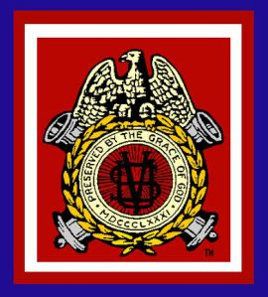
DEPARTMENT OF THE CHESAPEAKE
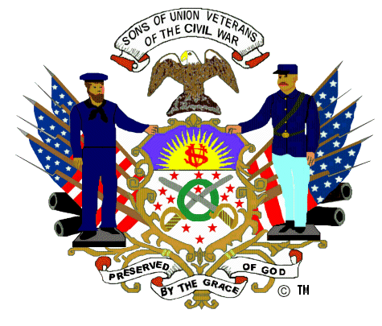
THE CHESAPEAKE GAZETTE
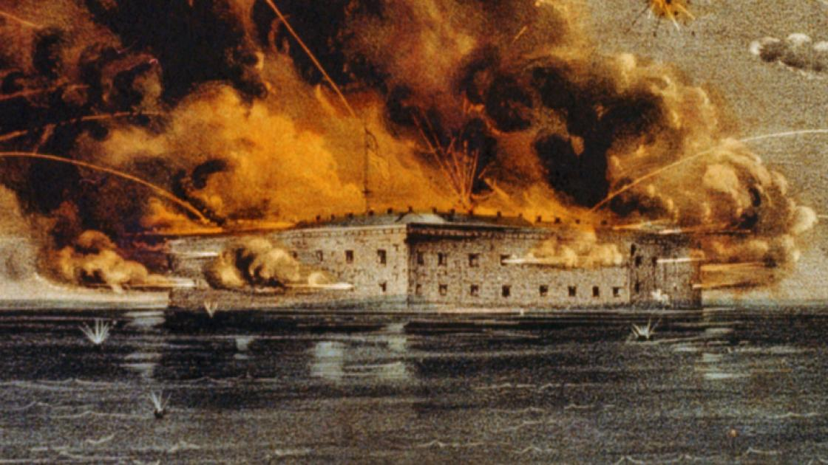
Bombardment of Fort Sumter by Currier & Ives

The Battle of Fort Sumter (April 12–13, 1861) was the bombardment of Fort Sumter near Charleston, South Carolina, by the South Carolina militia and the return gunfire and subsequent surrender by the United States Army.

Fiscal Year 2021 Department of the Chesapeake Officers
Commander - Jay Rarick
Senior Vice Commander - Roger Leturno
Junior Vice Commander - Brian Horgan
Secretary-Treasurer - Michael Beard
Patriotic Instructor - Tommy Chapman
Council - Faron Taylor, Mark Day, Timothy McCoy
Counselor - Andrew Johnson (Lincoln Cushing)
Chaplain - Dr. Clifton Potter
Assistant Treasurer - Michael Paquette
Eagle Scout Coordinator - Robert Stine
Graves Registration - Steve Hammond
Guide and Guard - Wes Mumper
Signals Officer - Mark Day
Color Bearer - Bob Heath
ROTC Coordinator - Roger Leturno
Aide de Camp - Andrew Johnson (Irish Brigade)
From the Editor in Chief (Senior Vice Commander)
This is my 3rd and final publication as this year’s Chesapeake Gazette Editor in Chief (SVC). It has been a pleasure producing our newsletter. I wish to thank the Camp Commanders that submitted their quarterly reports in accordance with Department Advisory #1. I sincerely hope all camps will submit articles once COVID-19 restrictions ease. By sharing activities through this publication, we close the Department’s geographical and pandemic distances.
All brothers should feel free to submit articles to the Gazette for publication. This is after all, your newsletter. Submissions and 4th Quarter reports should be consolidated at camp level and forwarded to the Department Senior Vice Commander no later than July 1, 2021. Feedback is always appreciated.
From the Department Commander’s Desk
Welcome to the latest installment of the Chesapeake Gazette! I hope that the stories you find within will encourage you to find and execute your own Camp projects. The 2020-2021 term of office for the Department is beginning to come to an end. It has been my distinct pleasure to serve as your Commander and to represent the Department of the Chesapeake.
Within this year I have tried to navigate the restrictions of the Pandemic and of the challenging times in which we live. I have reached out to the Camps, to other Departments, and to the National Office whenever I believed our voice needed to be heard, either in support, compassion, or counsel. It has been an honor to serve as installing officer for some of our Camps and to visit others…all on virtual platforms. I look forward to the days (coming soon, hopefully) wherein we may be together in person once again.
Until that time, continue to proudly remember and celebrate the “Boys in Blue” and our ancestors of the Grand Army of the Republic.
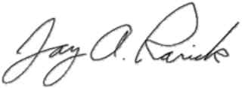
In Fraternity, Charity and Loyalty,

Jay A. Rarick, P.C.C.
Commander
Department of the Chesapeake
Sons of Union Veterans of the Civil War

Department Calendar
The 134th Encampment of the Department of the Chesapeake, SUVCW, will be held via Zoom on April 17, 2021, beginning at 8:00.
Instructions for credentialing delegates have been forwarded to the Camps by the Department Secretary.
Additional instructions for accessing and attending the Encampment can be found in Department Order #7 2020-21 and Department Advisory #11 2020-21. Both of these documents can be found in the right column of the Department website home page.
This year the ladies of the Department Auxiliary are holding their Annual Encampment one week later on April 24th.

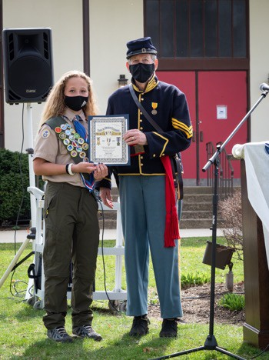
Appomattox Camp #2

On Saturday, March 27, 2021, Senior Vice Commander Ken Finlayson of Appomattox Camp #2, Department of the Chesapeake, presented the Sons of Union Veterans of the Civil War Eagle Scout Certificate to Scout Scarlett Helmecki. Scarlet, a member of Troop 1923 in Wilmington, Delaware, is the first girl to earn the Eagle Scout Rank BSA in the Del-Mar-Va Council of the Boy Scouts of America and the State of Delaware.

Taylor-Wilson Camp # 10
Brothers of Taylor-Wilson Camp #10 have begun to slowly emerge from the pandemic restrictions which greatly impaired many of our projects and plans during 2020. We are looking forward to 2021 and the promise of better times. We hope to report on several memorial tablets and grave markings we plan to complete in the coming months.
Last November, we held the second of two physical meetings during the pandemic crisis. During that meeting, held at “Edgewood,” the Antebellum home of SUVCW Brother Charles Nalls in Amherst, Virginia, we elected our officers for 2021. We are incredibly pleased to have PCinC Mark Day as Camp Commander, PCC Kevin Shroyer as SVC, and PCC Tim Ake as JVC. These three proven leaders will undoubtedly make the camp successful in the coming year.
In January and March, we held our regular camp meetings via Zoom conferencing. We were honored to have Department Commander Rarick and Department SCV Leturno join us for those meetings. Our camp is currently working on a major project to place a memorial tablet with the names of more than 300 Union Soldiers who died in the hospitals and Prisoner of War camp in Lynchburg, VA. Our current plan is to have the tablet placed on Lynchburg’s famed “Monument Terrace” sometime prior to Memorial Day 2022. We are also in the planning stages for a special observance of General Ulysses S. Grant’s 200th birthday in April 2022.
Several of our camp members have been continually active through living history presentations, lectures, and even research for a new book on the men who died in Lynchburg hospitals and Prisoner of War camps. Brother Kevin Shroyer lectured on Union Generals from Virginia. Brother Dr. Charles Driscoll, M.D., gave a virtual lecture on his book, The Incredible Story of an Iowa Civil War Medical Center, to a book club at a VA Health Center. He gave a separate Zoom presentation on another of his publications, John Jay Terrell, MD: Civil War Doctor to Man and Horse. Dr. Clifton Potter continues to work on his monograph about the more than 300 Union soldiers who died in Lynchburg’s Medical and POW facilities. Finally, CC Day will be presenting a living history impression of Major General Edward O. C. Ord at Sailors Creek on the 10th of April.
In May, Taylor-Wilson Camp #10 plans to have an in-person meeting in the picnic pavilion at American Legion Post 16 in Lynchburg. During that meeting we will conduct our traditional remembrance service for each of our ancestors who served in the Union Army. We will also place flags on the graves of more than 40 Union soldiers buried in our area of operations in Prince Edward, Appomattox, Campbell, Nelson, Bedford, and Rockbridge Counties. On Memorial Day, we will hold our annual program at the Quaker Church Burial Grounds in Lynchburg. This year we will honor the men of the 91st Ohio, nine of whom are buried at the cemetery. We recently discovered and are eager to mark two new Union graves just outside of South Boston in Pittsylvania County. Locally, we have a grave in a family cemetery for which we are working to get a marker.
As you can see, we have exciting months ahead. We have a busy schedule for the remainder of the year and we hope to invite you all to these programs and ceremonies.
Army of the James Camp #1864
Despite the COVID-19 pandemic, the Army of the James Camp #1864 had a very productive 3rd Quarter. The Camp welcomed into their ranks Brother Christopher J. Wampler, whose ancestor was Private Levi Selver, a soldier in Company H, 17th Illinois Infantry Regiment. Brother Wampler is a Virginia State Police Officer.
Commander Bartholf was published in the Richmond Postcard Club’s magazine. The story on his collection of GAR and SUV Patriotic postcards gave the Order some well received publicity in the former capital city of the Confederacy.
One of the Army of the James Camp #1864’s current projects is the recording of burial locations for its members’ Union ancestors. Commander Bartholf has personally recorded and researched over 1500 members of his ancestor’s civil war regiment. The camp is also looking into what they hope to be a joint project with the City of Richmond to spruce up the Libby Prison site and markers downtown.
Camp Bartholf proudly reports that all members have renewed their memberships and all reports were submitted on time in accordance with the Constitution and Regulations of the Sons of Union Veterans of the Civil War.

Colonel James D. Brady Camp #63
On January 26, 2021, Colonel James D. Brady Camp #63 installed new officers during this year’s first Zoom meeting.

Camp Commander - Tim Ahlgrim
Senior Vice Commander - Tal Vivian
Junior Vice Commander - Eric Kirk
Secretary and Treasurer - Ed Freyforgel
Patriotic Instructor - Kenneth Bage
Chaplain and Signals Officer - Jason L. Fite
Grave Registration Officer - Tom Grund
Civil War Memorials Officer - Albert P. Burckhard
Eagle Scout Coordinator - Steve von Hitritz
Council Members Louis - Mosier, Thomas L. Grund, William M. Butler

The Camp also welcomed its newest members, Mike Kiser and David Long.

With the Virginia Governor easing some of the mandated restrictions for outdoor gatherings, the Colonel James D. Brady Camp #63 has started planning in earnest for its annual Memorial Day ceremony at Cold Harbor Cemetery.

Irish Brigade Camp #4
The Irish Brigade Camp, like most camps in the Order, continues to face challenges brought on by the COVID-19 pandemic. That being said, this is a camp that is passionate about doing as much as current circumstances will allow. While most living history activities were curtailed by COVID-19, 2021 has seen a return of such events. In March 2021, several Irish Brigade camp members attended and participated in the annual Military through the Ages event at Jamestown Settlement. Brothers Brian Withrow and Jim Standard set up a re-creation of General Grant’s City Point headquarters. Portraying Generals Grant and Sheridan, these brothers engaged the public, informing visitors about the men they portray and the operations of the headquarters in late 1864 through early 1865. Several current and former camp members were able to attend.
While the camp continues to operate in a somewhat restricted mode, the camp looks forward to 2021, with future staff rides/tours and planning in progress for the 2022 Lincoln Dinner. Over the last year, the camp has grown, adding three new members. We remain hopeful for a fantastic year!
Joshua L. Chamberlain Camp # 20
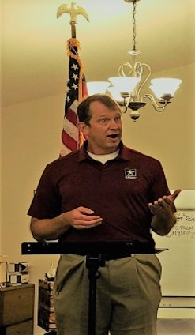
Unable to meet in January and February, the Joshua L. Chamberlain Camp #20 held a physical meeting on Tuesday, March 16, at St. Thomas of Canterbury Anglican Catholic Church, Roanoke, VA.
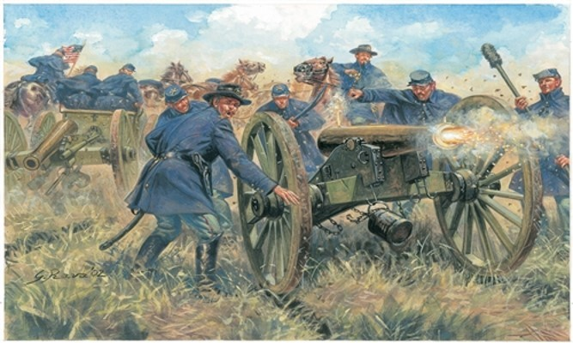
Guest speaker, US Army LTC (R) Minter S. Jackson, gave a captivating talk on “Union Artillery”.
During his presentation the Brothers were asked “During what civil war event did the Union utilize the most number of artillery?” Reponses included Antietam and Gettysburg. Surprisingly, the correct answer was the Defense of Washington, District of Columbia.
LTC (R) Jackson was presented a Certificate of Appreciation and Honorary Membership at the conclusion of his outstanding presentation.
General Alfred T.A. Torbert Camp # 1862
COVID-19 restrictions limited General T.A. Torbert Camp #1862 activities in 3rd Quarter. The Camp completed and submitted the Annual Camp Report, Form 27. 100% of its members renewed membership. The Camp also submitted the FY 2020 Form 990-N Postcard to the IRS.
The Camp Commander reports that a trip is planned to Gettysburg National Battlefield for a spring cleanup of the Adopt-A-Positions. Dates have not been set.

